**Day 2**

**Session 1**

**Angular Intro - Angular App Creation and Testing**

**Firstapp.component.html**

<h1>{{FavouriteMovie}}</h1>

<div>

<h1>{{Titles}}</h1>

<strong>Id:</strong>{{Id}}<br><br>

<strong>Name:</strong>{{Name}}<br><br>

<strong>Salary:</strong>{{Salary}}

<br><br>

<span *ngIf="Permanent"><strong>Permanent:</strong>Yes</span>

<br><br>

<strong>Department Id:</strong>{{Department_Id}}

<br><br>

<strong>Department Name:</strong>{{Department_Name}}

<br><br>

<strong>Skills</strong>

<br><br>

<span><strong>Skill Id Skill Name</strong></span>

<ol type="1">

<li *ngFor="let item of Skills">{{item}}</li>

</ol>

<strong>Date Of Birth: </strong>{{DateofBirth}}

<br><br>

<h1>Pipes</h1>

<strong>Id: </strong>{{Id}}<br><br>

<strong>Name: </strong>{{Name}}<br><br>

<strong>Salary: </strong>{{Salary | currency:"INR"}}

<br><br>

<span *ngIf="Permanent"><strong>Permanent:</strong>Yes</span>

<br><br>

<strong>Department Id: </strong>{{Department_Id}}

<br><br>

<strong>Department Name: </strong>{{Department_Name}}

<br><br>

<strong>Skills</strong>

<br><br>

<span><strong>Skill Id Skill Name</strong></span>

<ol type="1">

<li *ngFor="let item of Skills">{{item}}</li>

</ol>

<strong>Date Of Birth:</strong>{{DateofBirth | date}}

</div>

**Firstapp.component.ts**

import { Component, OnInit } from '@angular/core';

@Component({

selector: 'app-firstapp',

templateUrl: './firstapp.component.html',

styleUrls: ['./firstapp.component.css']

})

export class FirstappComponent implements OnInit {

constructor() { }

ngOnInit(): void {

}

title = 'angular-learning';

public FavouriteMovie:string = "Lord of the Rings";

public Titles:string = "Employee Details";

public Id:number=1;

public Name:string="John";

public Salary:number=10000;

public Permanent:boolean=true;

public Department_Id:number=1;

public Department_Name:string="payroll";

public Skills:string[]=["Html","Css","JavaScripts"];

public DateofBirth:Date=new Date('12/31/2000');

}

**Output**

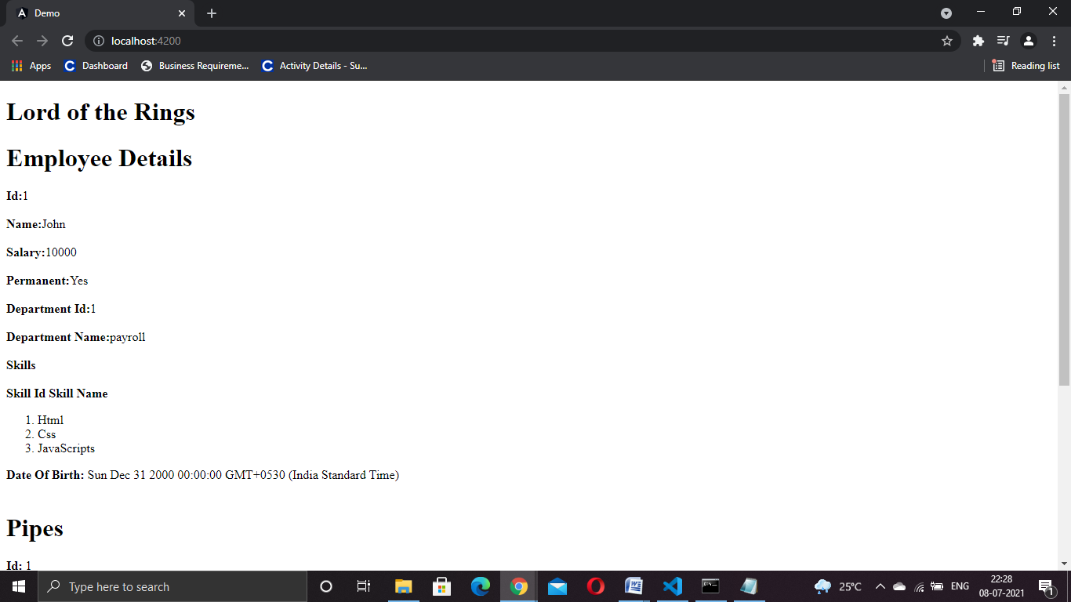

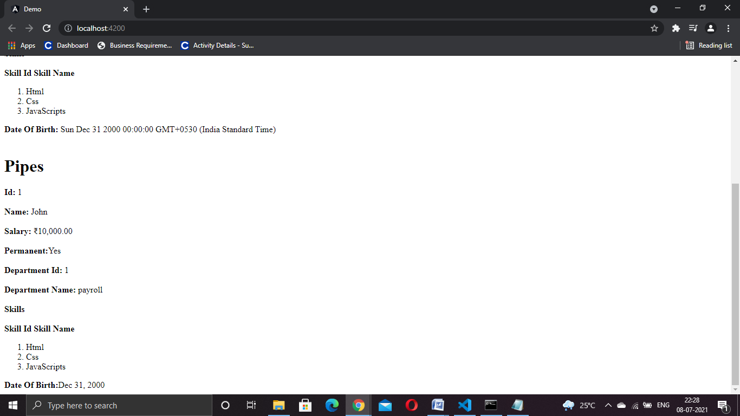

**Session 2**

**app.module.ts**

import

{ NgModule }

from '@angular/core';

import

{ BrowserModule }

from '@angular/platform-browser';

import

{ AppRoutingModule }

from './app-routing.module';

import

{ AppComponent }

from './app.component';

import

{ EditempComponent }

from './editemp/editemp.component';

import

{ QuantityIncrementComponent }

from './quantity-increment/quantity-increment.component';

import

{ ViewempsComponent }

from './viewemps/viewemps.component';

import

{ Routes,RouterModule}

from '@angular/router'

constappRoutes:Routes =[{ path: "" , component: ViewempsComponent},

{

path: "EditEmployees" ,

component: EditempComponent},{ path: "QuantityIncrement",component: QuantityIncrementComponent}]

@NgModule({

declarations:[

AppComponent,

ViewempsComponent,

EditempComponent,

QuantityIncrementComponent,

],

imports:[

BrowserModule,

AppRoutingModule,

RouterModule.forRoot(appRoutes)

],

providers:[],

bootstrap:[AppComponent]

})

export classAppModule{ }

**app.component.ts**

import

{ Component }

from '@angular/core';

import

{ Employee,Department}

from './interface-component';

@Component({

selector: 'app-root',

templateUrl: './app.component.html',

styleUrls:['./app.component.css'],

})

export classAppComponent

{

}

**App component.html**

< style >

body {

font - family: Segoe UI, Arial

}

a

{ text - decoration: none }

</ style >

< h3 > Angular Learning<br>< a[routerLink] = "['/']"> View Employees </ a > ||< a[routerLink] = "['/EditEmployees']"> Edit Employees </ a >||

< a[routerLink] = "['QuantityIncrement']"> Quantity Increment </ a ></ h3 >

< div >

< router - outlet ></ router - outlet >

**Quantity-increment.component.html**

< p > Simple Button click Event!!</p>

<button (click)= "firstbutton()"> Click Me </ button >

<br>

<br>

{ { result} }

<br>

< input type = "text" value ={ { num} }>< button(click) = "Add()"> add </ button >

<br>

<br>

< input type = "submit" value = "sub"(click) = "sub1()"[disabled] = "flag">< input type = "text" value ={ {addandsub} }>< input type = "submit" value = "add"(click) = "add1()">

**Quantity-increment.component.ts**

import

{ Component, OnInit }

from '@angular/core';

@Component({

selector: 'app-quantity-increment',

templateUrl: './quantity-increment.component.html'

})

export classQuantityIncrementComponent

{

publicresult:string="";

publicfirstbutton() :void{

this.result="click me button clicked";

}

publicnum:number = 0;

publicAdd():void

{

this.num++;

}

publicaddandsub:number = 0;

publicflag:boolean = true;

public add1():void

{

this.addandsub++;

if (this.addandsub> 0)

{

this.flag = false;

}

else

{

this.flag = true;

}

}

public sub1():void

{

this.addandsub--;

if (this.addandsub> 0)

{

this.flag = false;

}

else

{

this.flag = true;

}

}

}

**Edit.component.ts**

< p >editemp works! </ p >

**Edit.component.ts**

import

{ Component, OnInit }

from '@angular/core';

@Component({

selector: 'app-editemp',

templateUrl: './editemp.component.html'

})

export classEditempComponent implements OnInit

{

constructor() { }

ngOnInit(): void {

}

}

**Viewemps.component.html**

< strong > Id:</ strong >{ { Id} }<br><br>

< strong > Name:</ strong >{ { Name} }<br><br>

< strong > Salary:</ strong >{ { Salary | currency:"INR"} }

<br><br>

< span * ngIf = "Permanent">< strong > Permanent:</ strong > Yes </ span >

<br><br>

< strong > Department Id:</ strong >{ {Department_Id} }

<br><br>

< strong > Department Name:</ strong >{ {Department_Name} }

<br><br>

< strong > Skills </ strong >

<br><br>

< span >< strong > Skill Id Skill Name</strong></span>

<ol type="1">

<li *ngFor="let item of Skills">{{item}}</ li >

</ ol>

<br>

<br>

< strong > Date Of Birth:</ strong >{ {DateofBirth | date} }

**Viewemps.component.ts**

import

{ Component, OnInit }

from '@angular/core';

@Component({

selector: 'app-viewemps',

templateUrl: './viewemps.component.html'

})

export classViewempsComponent

{

publicId:number=1;

publicName:string="John";

publicSalary:number=10000;

publicPermanent:boolean=true;

publicDepartment_Id:number=1;

publicDepartment_Name:string="payroll";

publicSkills:string[]=["Html","Css","JavaScripts"];

publicDateofBirth:Date=newDate('12/31/2000');

}

**Output:**

